Day 5 assignment

1. i) Describe how histogram charts are created in R. Create a histogram chart for the

below given age attribute.

Age : 5,45,23,30,33,32,34,35,42,41,28,29

ii) Create a 3D Pie Chart for the dataset “political Knowledge” with suitable

labels and colour.

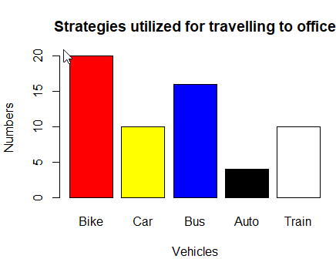

CODE:

1)i)age <- c(5, 45, 23, 30, 33, 32, 34, 35, 42, 41, 28, 29)

hist(age, main = "Age Distribution", xlab = "Age", ylab = "Frequency")

ii)library(plotrix)

political_knowledge <- c("Low", "Low", "Medium", "Medium", "High", "High", "High")

pie3D(table(political_knowledge), main = "Political Knowledge",

col = c("red", "orange", "green"), explode = 0.1)

2. Write R code for the below output Figure 1 shows Bike is assigned red , car is

assigned yellow , bus is assigned blue , auto is assigned black , and train is assigned

white. Mention the parameters used in the below barchart.

CODE:

# Load the mtcars dataset

data(mtcars)

# Create a boxplot graph of mpg by cyl

boxplot(mpg ~ cyl, data = mtcars, xlab = "Number of Cylinders", ylab = "Miles per Gallon",

main = "Relationship between MPG and Cylinders")

# Define a recursive function to find the sum of n natural numbers

sum_natural <- function(n) {

if (n == 0) { # Base case: sum of 0 numbers is 0

return(0)

} else { # Recursive case: sum of n numbers is n + sum of (n-1) numbers

return(n + sum_natural(n-1))

}

}

# Test the function with n = 10

sum_natural(10) # Output: 55

3. Create a Boxplot graph for the relation between &quot;mpg&quot;(miles per galloon) and

&quot;cyl(number of Cylinders) for the dataset &quot;mtcars&quot; available in R Environment.

v)Write R program to find the sum of Natural Numbers using Recursion

CODE:

# Load the mtcars dataset

data(mtcars)

# Create a boxplot graph of mpg by cyl

boxplot(mpg ~ cyl, data = mtcars, xlab = "Number of Cylinders", ylab = "Miles per Gallon",

main = "Relationship between MPG and Cylinders")

# Define a recursive function to find the sum of n natural numbers

sum_natural <- function(n) {

if (n == 0) { # Base case: sum of 0 numbers is 0

return(0)

} else { # Recursive case: sum of n numbers is n + sum of (n-1) numbers

return(n + sum_natural(n-1))

}

}

# Test the function with n = 10

sum_natural(10) # Output: 55

4. a. Melt ‘airquality’ data set which inbuild dataset in ‘R’ and display as a long – format

data?

b. Melt air quality data and specify month and day to be “ID variables”?

c. Cast the molten ‘airquality’ data set.

d. Use cast function appropriately and compute the average of Ozone, Solar, Wind

and temperature per month?

e. Create a boxplot for ozone reading of ‘airquality’ dataset. Add title, label and color.

CODE:

4)a)library(reshape2)

data(mtcars)

airquality_melt <- melt(airquality)

b)airquality_melt <- melt(airquality, id.vars = c("Month", "Day"))

head(airquality_melt)

c)airquality_cast <- dcast(airquality_melt, Month ~ variable)

head(airquality_cast)

d)library(plyr)

airquality_avg <- cast(airquality_melt, Month ~ variable, mean)

head(airquality_avg)

e)library(ggplot2)

ggplot(data = airquality, aes(x = "", y = Ozone)) +

geom_boxplot(fill = "lightblue", color = "blue") +

labs(title = "Boxplot of Ozone Readings", y = "Ozone Reading")

head(airquality_melt)

5. a. Write a program for creating a pie-chart in R using the input vector (21,62,10,53).

Provide labels for the chart as ‘London’, ‘New York’, ‘Singapore’, ‘Mumbai’. Add a

title to the chart as ‘city pie-chart’ and add a legend at the top right corner of the chart.

b. Using linear regression analysis establish a relationship between height and weight

of a person using the input vector given below.

# Values of height

151, 174, 138, 186, 128, 136, 179, 163, 152, 131

# Values of weight.

63, 81, 56, 91, 47, 57, 76, 72, 62, 48 Predict the weight of a person with height 170.

c. Visualize the regression graphically.

d. Call ‘mtcars’ which is built in dataset in ‘R’ and plot distribution of mpg feature.

Make x axis range from 10 to 35 and plot title as “More trends in 70’s Vehicles”.

e. Find statistical summary of the ‘mtcars’ dataset.

CODE:  
# Input vector

> # Input vector

> input_vector <- c(21, 62, 10, 53)

> # Labels for chart

> labels <- c("London", "New York", "Singapore", "Mumbai")

> # Create pie chart

> pie(input_vector, labels = labels, main = "City Pie Chart")

> # Add legend

> legend("topright", legend = labels, fill = rainbow(length(labels)))

> # Input vectors

> height <- c(151, 174, 138, 186, 128, 136, 179, 163, 152, 131)

> weight <- c(63, 81, 56, 91, 47, 57, 76, 72, 62, 48)

> # Perform linear regression

> fit <- lm(weight ~ height)

> # Predict weight for height 170

> predict(fit, data.frame(height = 170))

1

76.22869

> # Create scatter plot

> plot(height, weight, main = "Height vs Weight")

> # Add regression line

> abline(fit, col = "red")

> # Set x-axis range

> x_range <- c(10, 35)

> # Create histogram

> hist(mtcars$mpg, xlim = x_range, main = "More Trends in 70's Vehicles", xlab = "MPG")

> e)summary(mtcars)

6. There is a popular built-in data set in R called &quot;mtcars&quot; (Motor Trend Car Road Tests),

which is retrieved from the 1974 Motor Trend US Magazine.

(i)Find the dimension of the data set &amp; Give the statistical summary of the features.

(ii)Create correlation matrix between mpg vs all other features and print the high 3

correlated Features(both +ve and -ve)

(iii)Plot the Box plot for “mpg” group by “cyl” feature.

(iv)Create a scatter plot graph for the relation between &quot;mpg&quot;(miles per gallon) and

&quot;hp&quot;(horse power) group by cyl(number ofcylinder)

Sample Output:

(v) Generate a multiple regression model to establish the relationship between &quot;mpg&quot;

as a response variable with &quot;disp&quot;,&quot;hp&quot; and &quot;wt&quot; as predictor variables. Plot the

regression line. Find the MSE of the model.

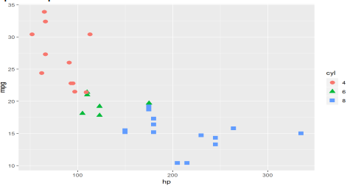

CODE:

data(mtcars)

> # Dimensions of the data set

> dim(mtcars)

[1] 32 11

> # Statistical summary of the features

> summary(mtcars)

mpg cyl disp hp drat

Min. :10.40 Min. :4.000 Min. : 71.1 Min. : 52.0 Min. :2.760

1st Qu.:15.43 1st Qu.:4.000 1st Qu.:120.8 1st Qu.: 96.5 1st Qu.:3.080

Median :19.20 Median :6.000 Median :196.3 Median :123.0 Median :3.695

Mean :20.09 Mean :6.188 Mean :230.7 Mean :146.7 Mean :3.597

3rd Qu.:22.80 3rd Qu.:8.000 3rd Qu.:326.0 3rd Qu.:180.0 3rd Qu.:3.920

Max. :33.90 Max. :8.000 Max. :472.0 Max. :335.0 Max. :4.930

wt qsec vs am gear

Min. :1.513 Min. :14.50 Min. :0.0000 Min. :0.0000 Min. :3.000

1st Qu.:2.581 1st Qu.:16.89 1st Qu.:0.0000 1st Qu.:0.0000 1st Qu.:3.000

Median :3.325 Median :17.71 Median :0.0000 Median :0.0000 Median :4.000

Mean :3.217 Mean :17.85 Mean :0.4375 Mean :0.4062 Mean :3.688

3rd Qu.:3.610 3rd Qu.:18.90 3rd Qu.:1.0000 3rd Qu.:1.0000 3rd Qu.:4.000

Max. :5.424 Max. :22.90 Max. :1.0000 Max. :1.0000 Max. :5.000

carb

Min. :1.000

1st Qu.:2.000

Median :2.000

Mean :2.812

3rd Qu.:4.000

Max. :8.000

> # Correlation matrix between mpg and other features

> correlations <- cor(mtcars)

> # Sort the correlations by the absolute values

> correlations_sorted <- sort(abs(correlations[,'mpg']), decreasing = TRUE)

> # Print the top three highest correlated features

> correlations_sorted[1:3]

mpg wt cyl

1.0000000 0.8676594 0.8521620

7. (i) Use melt and cast function to find mean of numeric data in dataset based on

Species group.

(ii) Generate a suitable plot which summaries statistical parameter of Sepal.Width

based on Species group

(iii) Generate scatter plot between Sepal.Length vs Sepal.Width grouped by Specias.

Sample Output:

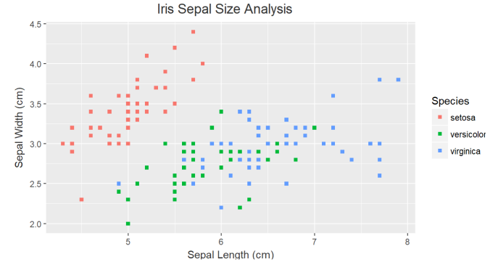

CODE:  
7)a)# Load the reshape2 package

library(reshape2)

# Melt the iris data set

melted_iris <- melt(iris, id.vars = 'Species')

# Cast the molten data set to find the mean of the numeric variables based on the species group

mean_iris <- dcast(melted_iris, Species ~ variable, mean)

# View the mean_iris data frame

mean_iris

b)# Load the ggplot2 package

library(ggplot2)

# Create a box plot of Sepal.Width grouped by Species

ggplot(iris, aes(x = Species, y = Sepal.Width)) +

geom_boxplot() +

ggtitle("Box plot of Sepal.Width by Species")

c)# Create a scatter plot of Sepal.Length vs Sepal.Width grouped by Species

ggplot(iris, aes(x = Sepal.Length, y = Sepal.Width, color = Species)) +

geom_point() +

ggtitle("Scatter plot of Sepal.Length vs Sepal.Width by Species")

8. A) Heights(in cm) of father and son are given as follows

Father(X): 150 152 155 157 160 161 164 165

Son (Y) : 154 156 158 159 160 162 161 164

Fit a regression line parameters to predict the height of son given the height of father.

Write R code for same.

B) Fit a regression line parameters distribution with the following data

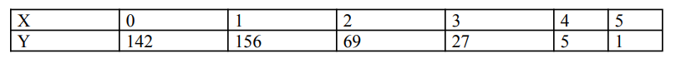

CODE:

# Heights of father and son

father_height <- c(150, 152, 155, 157, 160, 161, 164, 165)

son_height <- c(154, 156, 158, 159, 160, 162, 161, 164)

# Fit a regression line to predict the height of son given the height of father

regression_model <- lm(son_height ~ father_height)

# Print the summary of the regression model

summary(regression_model)

B)# Fit a regression line to the data

regression_model <- lm(y ~ x, data = data_df)

# Print the summary of the regression model

summary(regression_model)